Extended Abstract Title (Font Times New Roman 16 Bold)

¹First Author*, ²Second Author, ³Third Author (Font Times New Roman 12 Bold)

¹First Author Affiliation, ²Second Author Affiliation, ³Third Author Affiliation (Affiliation Use Font Times New Roman 11)

*Corresponding Author email

ABSTRACT / ABSTRAK

Put your abstract here. Use single spacing. Abstract are written preferably from 100 to 250 words. The abstract should be clear, descriptive and should provide brief information to the problem. This should generally be followed by a statement regarding the methodology and a summary of results. The abstract should end with a comment on the significance of the result or a brief conclusion. Extended Abstract must be written in English or in Bahasa Malaysia.

Keywords: Maximum of 5 keywords separated by comma (,) Capital letters for each keyword.

INTRODUCTION / PENGENALAN

Use Times New Roman 10. Do not indent the first line of paragraph following a heading or sub heading. Use single spacing for main document. Note that there is only one space between sentences. Papers should be submitted online through the FOTLI2026 website and other requirements should be followed as in the Guide to Authors. All extended abstracts will be included in the FOTLI2026 Proceedings.

The manuscript article should be written in English in the font of Times New Roman, which includes the following: introduction, results and discussions, conclusion, acknowledgement and references. Manuscripts should be prepared via the Microsoft Word processor. Do not indent the first line of paragraph following a heading or sub heading. Use the APA reference style (Yoon, Kho, & Kim, 2017) for the extended abstract (Korytov, 2018).

RESULTS AND DISCUSSION / KEPUTUSAN DAN PERBINCANGAN

The number of pages for the extended abstract may vary from minimum of 2 pages to the maximum of 4 pages in A4 size. Authors are required to strictly advise to adhere to this limit. Manuscript with less than 2 pages or exceeding 4 pages may be unable to be included in the proceedings.

Format and save your graphic images using a suitable graphics processing program that will allow you to resize them and adjust the resolution settings. Use SI as primary units. Be sure that the symbols in your equation have been defined before the equation appears or immediately following. Number equations consecutively with equation numbers in parentheses flush. First use the equation editor to create the equation. Use the table format as shown below:

$\int_{-∞}^{∞}{}ψ\left(t\right)dt=0$ (1)

Table 1. Include with captions Font Times New Roman 8

Kaedah | RMKD | R2 | Nilai Ramalan
Kaedah 1 | 0.0000426 | 0.924 | 0.132
Kaedah 2 | 0.0000373 | 0.976 | 0.1278
Kaedah 3 | 0.000389 | 0.521 | 0.064

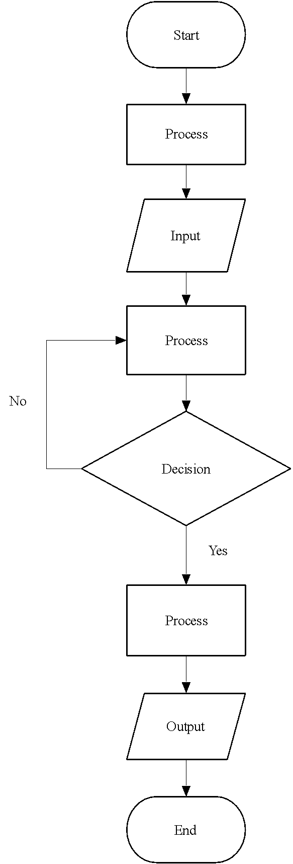

Fig. 1 Include with captions Font Times New Roman 8

CONCLUSION / KESIMPULAN

A conclusion to review the main points of the paper, do not replicate the abstract as the conclusion. A conclusion might elaborate on the importance of the work or suggest applications and extensions.

ACKNOWLEDGEMENT / PENGHARGAAN

Sponsor and financial support acknowledgments can be mentioned here.

REFERENCES / RUJUKAN

All publications cited in the text should be included in the reference list. Reference should be listed in using the APA reference style. Example of references can be from books, journal publication, conference proceedings and websites. Example of references appear in the text. Simple example of a references:

Korytov, M. (2018). Aspects of using ground and above-ground transport for urban passenger transportation. Transportation Research Procedia, 36, 341–346. https://doi.org/10.1016/j.trpro.2018.12.105
Yoon, S., Kho, S.-Y., & Kim, D.-K. (2017). Effect of Regional Characteristics on Injury Severity in Local Bus Crashes. Transportation Research Record: Journal of the Transportation Research Board, 2647(September), 1–8. https://doi.org/10.3141/2647-01

EXTENDED ABSTRACT GUIDELINE

• Tajuk (Font Times New Roman, 16, Bold)
• Nama (Font Times New Roman, 12, Bold)
• Afiliasi (Font Times New Roman, 11)
• Teks dan Equations (Times New Roman, 10)
• Jadual dan Rajah (Sertakan dengan kapsyen, Font Times New Roman, 8)
• Panjang penulisan extended abstract antara 2-4 muka surat sahaja.

Extended Abstract must be written in English or Bahasa Malaysia.

